**Lab Practical #12:**

Study & Survey of Institute organization network infrastructure.

**Practical Assignment #12:**

1. **Identify type of network in your institute. Draw a design of network in your institute (Any Lab/Floor/Building).**

**Lab No: C- 302**

**Topology: Star Topology**

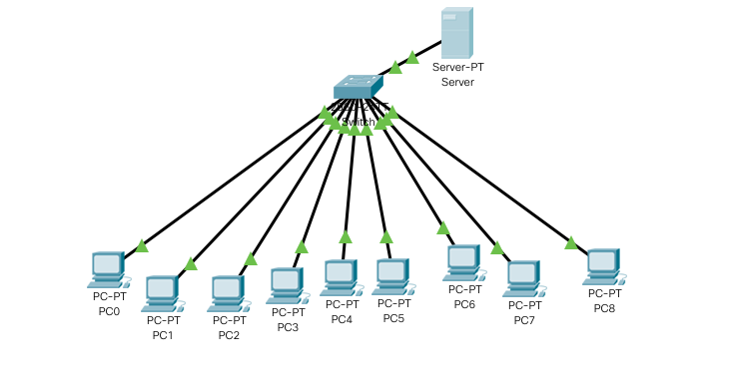

1. **List how many network devices and types of cable used and give its details.**

Total No Of PC: - 9

Total Number of Switch: - 1

Total Server: DHCP Server

Types Of Cable: - Twisted Pair Cable

Connectors: RJ-45

Network Type: Lan